API SIGMA
No | Nama API | Fungsi | Screenshoot
1 | /sigma/v1/stocksilo/getStockSILO | Get Stock Silo | 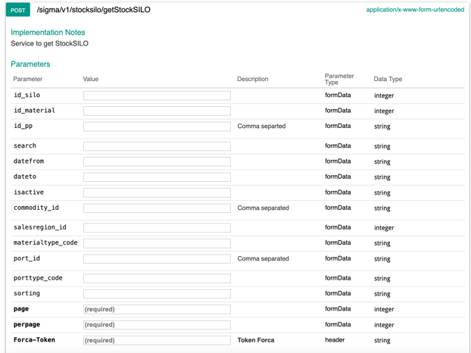
2 | /sigma/v1/stocksilo/saveStockSILO | Save Stock Silo Transaction | 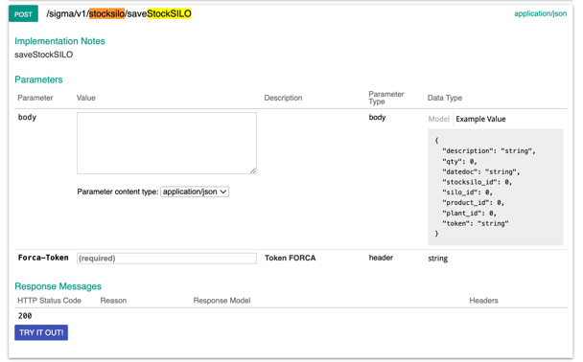
3 | /sigma/v1/stocksilo/deleteStockSILO | Delete Stock Silo Transaction | 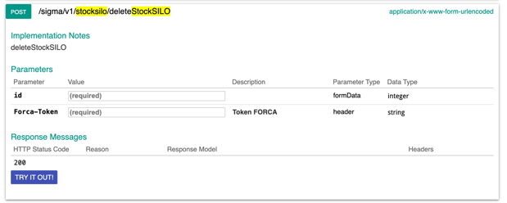
4 | /sigma/v1/resource/getSILO | Get Silo Master | 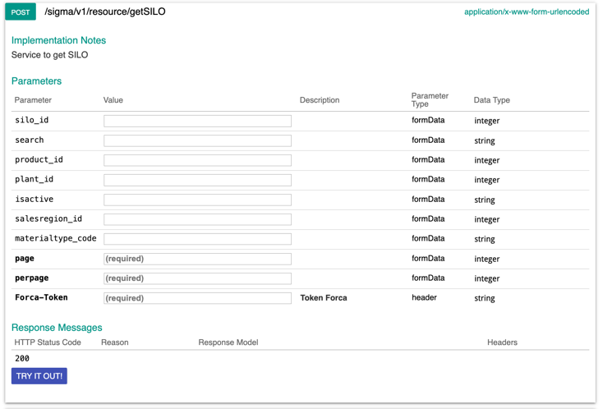
5 | /sigma/v1/resource/deleteSILO | Delete Silo Master | 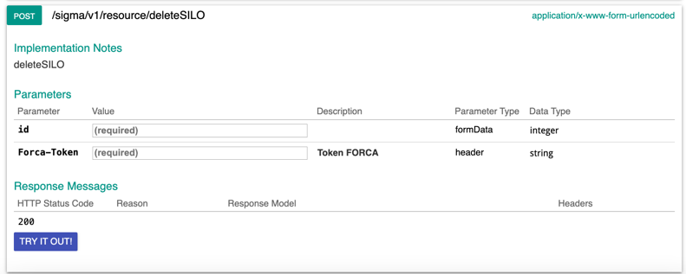
6 | /sigma/v1/resource/saveSILO | Save Silo Master | 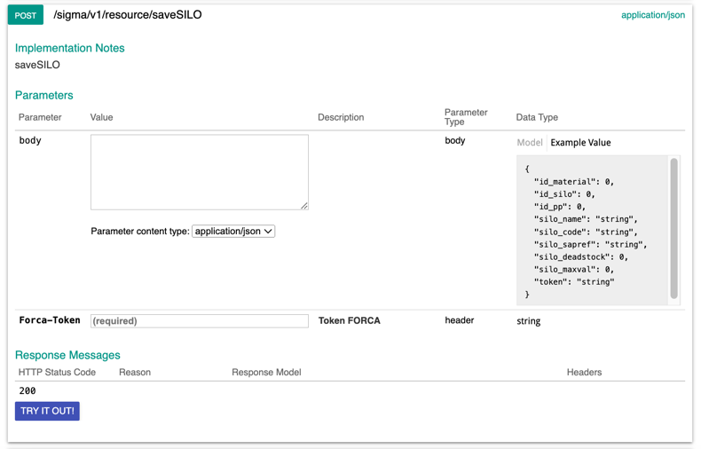
7 | /sigma/v1/vessel-position/getLastPosition | Get Last Position | 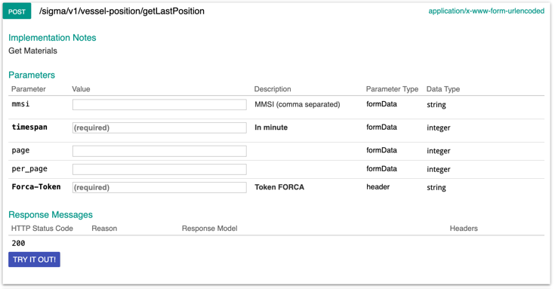
8 | /sigma/v1/resource/port/getPort | Get Port | 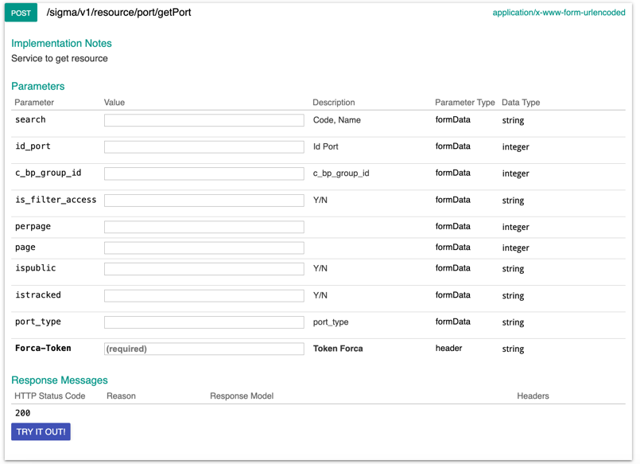
9 | /sigma/v1/availabilitytrans/getAvailabilityTrans | Get Availability Transaction | 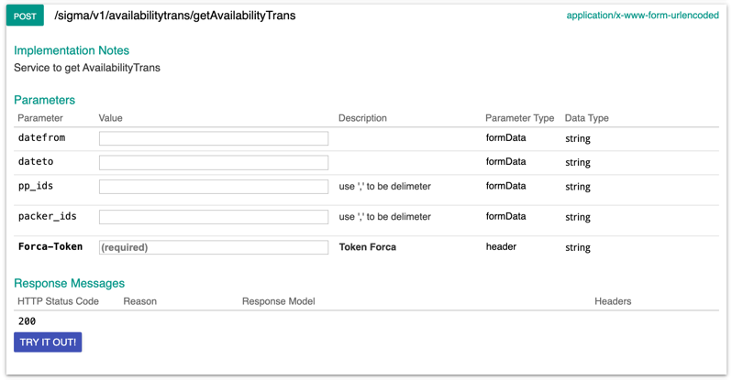
10 | /sigma/v1/availabilitytrans/saveAvailabilityTrans | Save Availability Transaction | 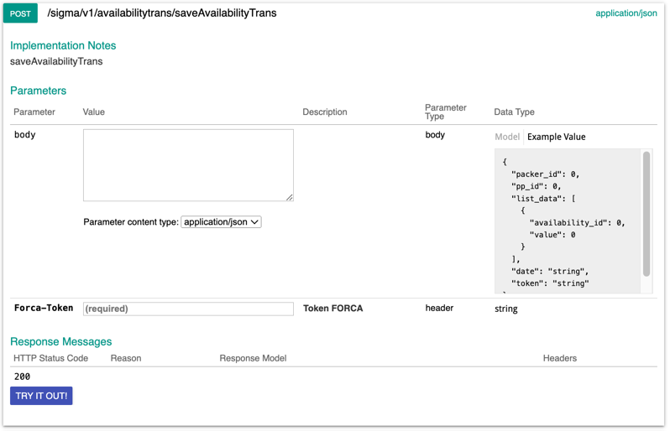
11 | /sigma/v1/availabilitytrans/deleteAvailabilityTrans | Delete Availability Transaction | 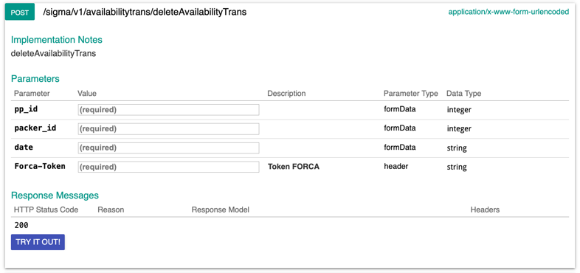
12 | /sigma/v1/availability/getAvailability | Get Availability Master | 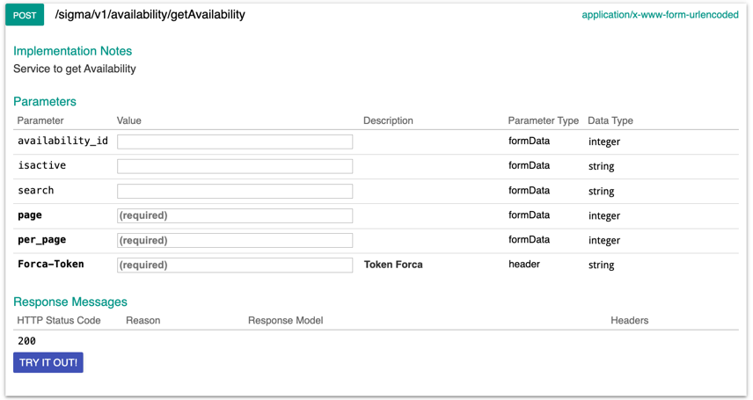
13 | /sigma/v1/availability/saveAvailability | Save Availability Master | 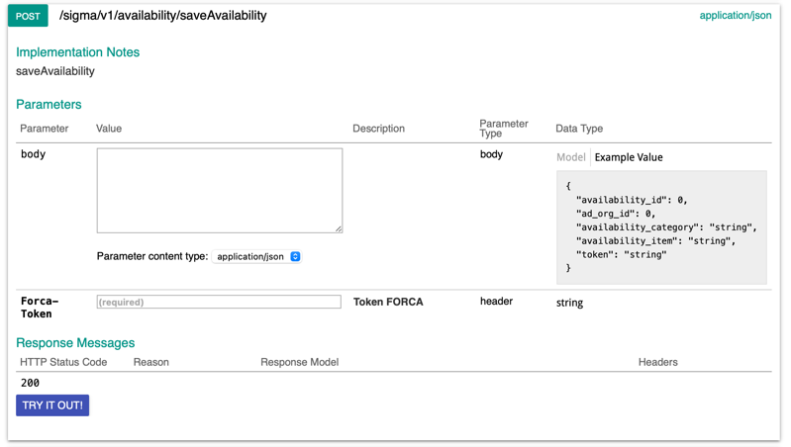
14 | /sigma/v1/availability/saveAvailability | Save Availability Master | 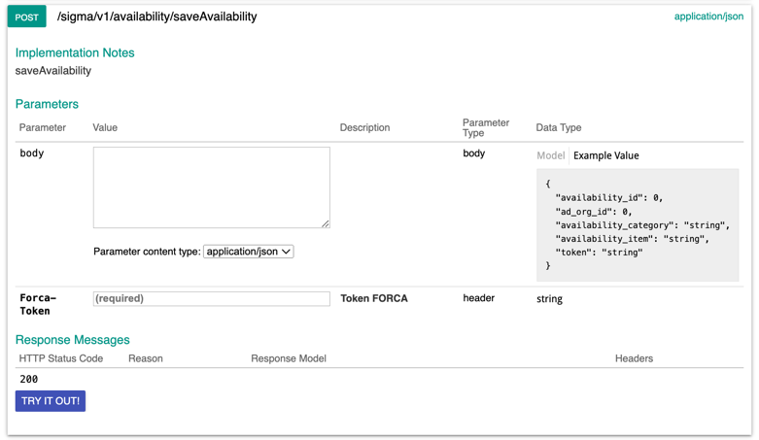
15 | /sigma/v1/availability/deleteAvailability | Delete Availability Master | 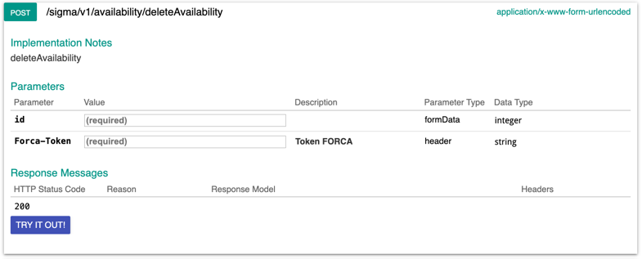
16 | /sigma/v1/jettyOperation/getLoadDischRateKade_Chart | Get Chart Loading Rate Per KD | 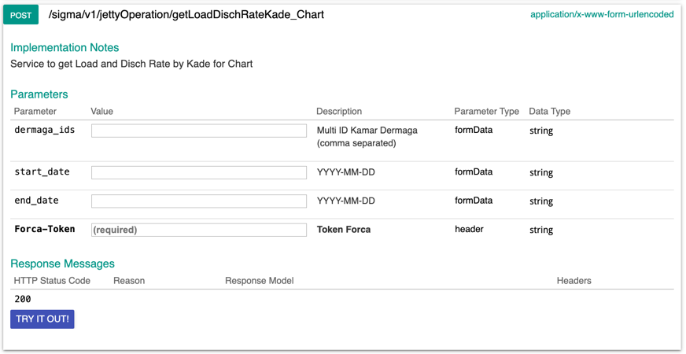
17 | /sigma/v1/jettyOperation/getLoadDischRateKade | Get Loading Rate Per KD | 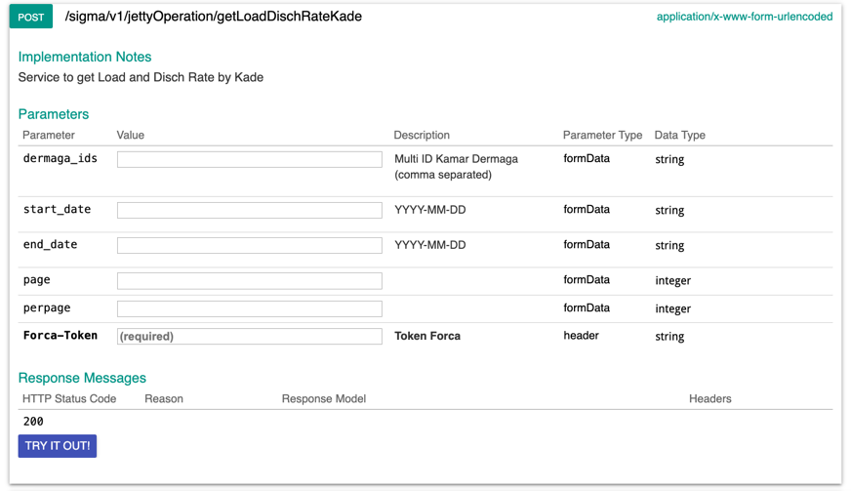
18 | /sigma/v1/jettyOperation/getLoadDischRateKomoditi_Chart | Get Chart Loading Rate Per Commodity | 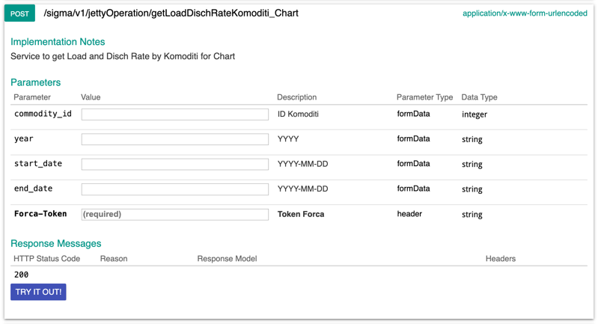
19 | /sigma/v1/jettyOperation/getLoadDischRateKomoditi_perVessel | Get Loading Rate Per Vessel | 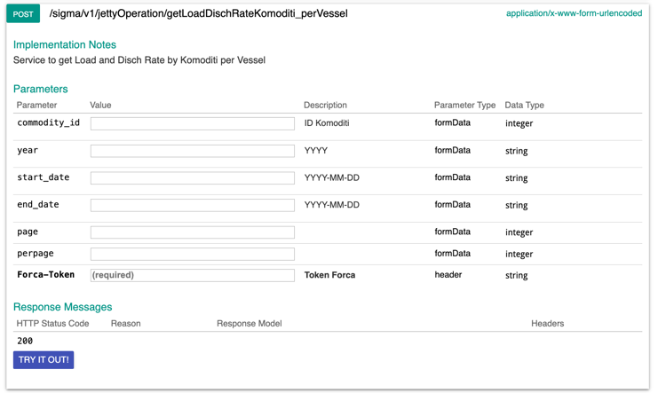
20 | /sigma/v1/jettyOperation/getLoadDischRateKomoditi_perDate | Get Loading Rate Per Commodity | 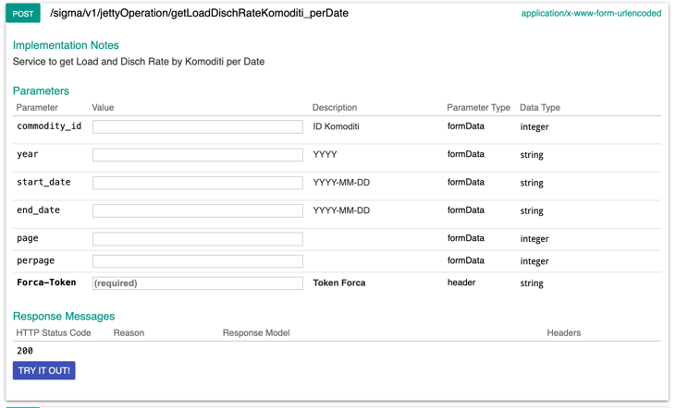
21 | /sigma/v1/jettyOperation/getLoadDischRateVessel_Chart | Get Chart Loading Rate Per Vessel | 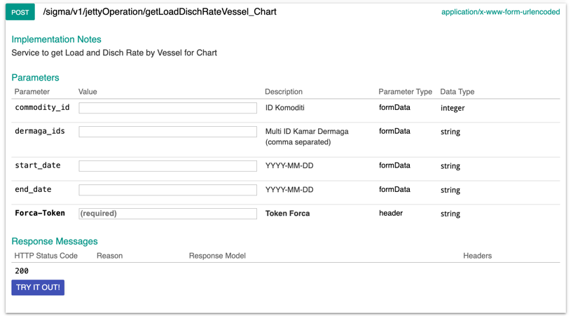
22 | /sigma/v1/jettyOperation/getLoadDischRateVessel | Get Loading Rate by Vessel | 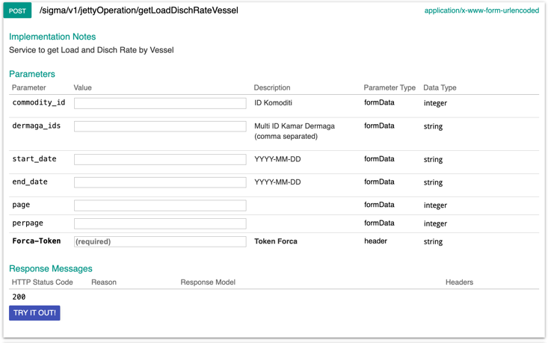
23 | /sigma/v1/unavailabilitytrans/getUnAvailabilityTrans | Get Un Availability Transaction | 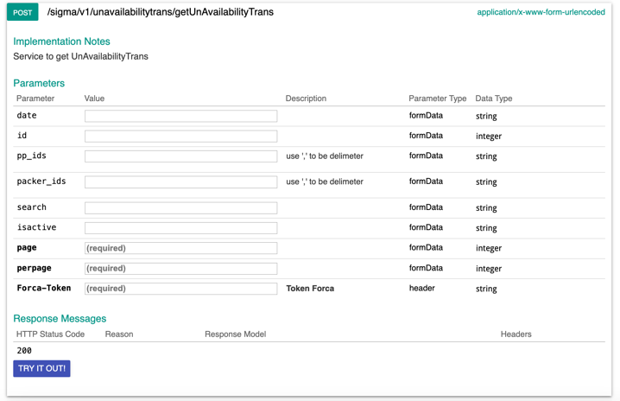
24 | /sigma/v1/unavailabilitytrans/saveUnAvailabilityTrans | Save Un Availability Transaction | 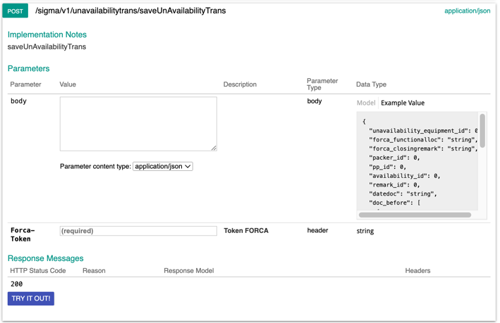
25 | /sigma/v1/unavailabilitytrans/deleteUnAvailabilityTrans | Delete Un Availability Transaction | 